**Project Design Phase-II**

**Data Flow Diagram & User Stories**

|  |  |
| --- | --- |
| Date | 26-06-2025 |
| Team ID | LTVIP2025TMID59482 |
| Project Name | ALPHA Works – FreelanceFinder |
| Maximum Marks | 4 Marks |

**Data Flow Diagrams:**

A **Data Flow Diagram (DFD)** illustrates how data moves within the **FreelanceFinder platform**. It captures user interactions (freelancers, clients, admins), internal processing (project posting, bidding, messaging, payments), and the storage of data (user profiles, messages, transaction logs).

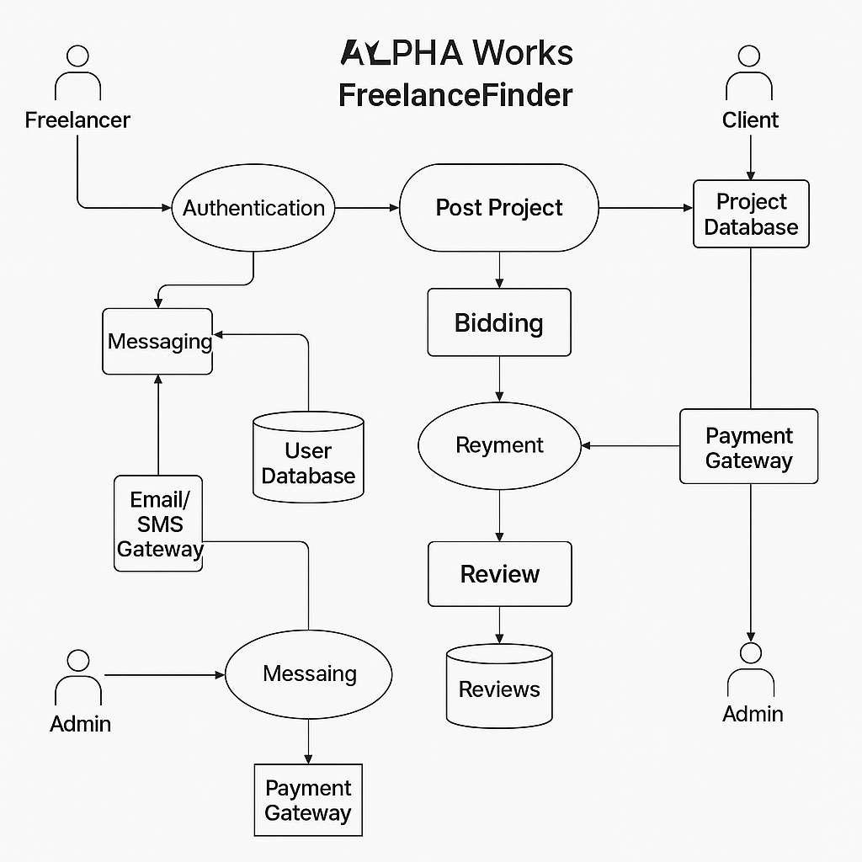

**User Stories**

**User Story Table – DocSpot**

|  |  |  |  |  |  |
| --- | --- | --- | --- | --- | --- |
| **User Type** | **Functional Requirement (Epic)** | **User Story / Task** | **Acceptance Criteria** | **Priority** | **Release** |
| |  | | --- | | **Freelancer** |  |  | | --- | |  | | |  | | --- | | Project Discovery & Bidding | | As a freelancer, I can search and filter relevant projects. | Projects returned match the selected filters. | High | Sprint-1 |
|  |  | As a freelancer, I can bid on projects. | |  | | --- | | Bid is visible to the client. |  |  | | --- | |  | | High | Sprint-1 |
| |  | | --- | | **Client** |  |  | | --- | |  | | |  | | --- | | Project Posting & Payment |  |  | | --- | |  | | |  | | --- | | As a client, I can post a new freelance project. | | |  | | --- | | Project is saved and listed for freelancers. |  |  | | --- | |  | | High | Sprint-1 |
| **User** | Messaging | As a user, I can chat with the other party in real-time. | Messages appear instantly. | Medium | Sprint-2 |
| **Admin** | Profile Management | As a Admin, I can update my profile. | Changes are saved successfully. | High | Sprint-2 |
| **Client** | Payment Processing | As a client, I can make secure payments after job completion. | Payment recorded and shown in transaction history. | High | Sprint-2 |
| **user** | |  | | --- | |  |  |  | | --- | | Review System | | As a user, I can leave a review after project closure. | Review appears on profile. | Medium | Sprint-2 |
| **Admin** | User Moderation | As an admin, I can review reported users and take action. | Reports and actions logged. | High | Sprint-1 |